Be Sure
Matthew 7:15-23

Most of you know that I grew up in Chicago. And my family had a lake house in Wisconsin, so I spent more time in southern Wisconsin than I did in the city of Chicago. We had a little motorboat and loved to take people water skiing or tubing. My brother and I had a little system to get the boat fueled up and ready for people. One of us would go get the ethanol-free gas, and the other would get the boat down off the lift and into the water.

One time, my brother was teaching another friend how to get the boat ready, with the canopy to give the driver shade. On both sides of the fold-out canopy, there was a metal pin that held it to a plastic keeper on the boat. My brother held the metal pin up over the muddy brown water to teach the new guy how important it was at this point NOT TO drop the pin, because it would sink into mud that was 12 inches deep and we would never find it again. He said, “Now, whatever you do…” and at that point something startled him, and he dropped the pin right into the water. Plunk. Gone.

I’m sure you have things like this that are unique and important to you. Maybe it’s special glasses or dishes that you only use for Christmas. You are extra careful in taking them out and move slowly when using them. Maybe it’s a Lego X-wing fighter your family bought for you when you turned 40, and you still display it on a shelf upstairs. These are purely hypothetical, you know.

Maybe the thing that is extra special to you and that you take extra care with is a PERSON. Maybe there is a newborn baby in your family, and you teach the older kids to be extra careful around the baby. You show them how to hold the precious little one to protect her head and neck. You don’t let them roughhouse by the little one so a football doesn’t fling across the room and whack her face. Might bounce off and hit the Lego set.

What we are extra careful with and protective of tells us something about our priorities and values. Let’s turn back to Matthew 3 and 4 so we can see the setup to the Sermon on the Mount in the beginning of the ministry of John the Baptist and the Lord Jesus. What was important to them as they began to preach?
But when he saw many of the Pharisees and Sadducees coming to his baptism, he said to them, “You brood of vipers! Who warned you to flee from the wrath to come? Bear fruit in keeping with repentance. And do not presume to say to yourselves, ‘We have Abraham as our father,’ for I tell you, God is able from these stones to raise up children for Abraham. Even now the axe is laid to the root of the trees. Every tree therefore that does not bear good fruit is cut down and thrown into the fire.” Matthew 3:7-10
Now, that seems pretty serious from John, doesn’t it? The axe at the root of the trees. Clearly, those trees refer to people, in particular the Jewish people coming out to hear John – the new prophet in the wilderness. Many are coming to be baptized as a sign of fresh commitment to the Lord, the God of Israel. What did baptism mean?
“I baptize you with water for repentance, but he who is coming after me is mightier than I, whose sandals I am not worthy to carry. He will baptize you with the Holy Spirit and fire. His winnowing fork is in his hand, and he will clear his threshing floor and gather his wheat into the barn, but the chaff he will burn with unquenchable fire.” Matthew 3:11-12
See, John’s assignment was to point ahead to Jesus, to prepare the way for the arrival of the Messiah. How did John the Baptist describe the ministry of Jesus? A ministry of ingathering, of harvest, but also of SEPARATION. The wheat will be gathered in but also separated from the chaff, which will be burned up with UNQUENCHABLE FIRE.

So, John’s message was very clear. Yes, come to be baptized. But be sure your baptism represents true repentance. Don’t try to fake it. You might fool me, John said, but you won’t fool the Messiah coming after me. He will not just baptize with water, but also with the Holy Spirit, and will test and separate true followers from false ones with an immersion in FIRE.

And how did Jesus begin His ministry?

From that time Jesus began to preach, saying, “Repent, for the kingdom of heaven is at hand.” Matthew 4:17

Jesus picked up the same message John started with: a call to REPENT. Turn away from this world because a new kingdom is arriving: the kingdom of the skies. The only ones who will make it into the kingdom of HEAVEN are those who repent and turn away from the kingdom of this world. Listen to these repeated warnings in the first few chapters of Matthew and especially in the Sermon on the Mount. Jesus opened his preaching with the same word John the Baptist used: REPENT.

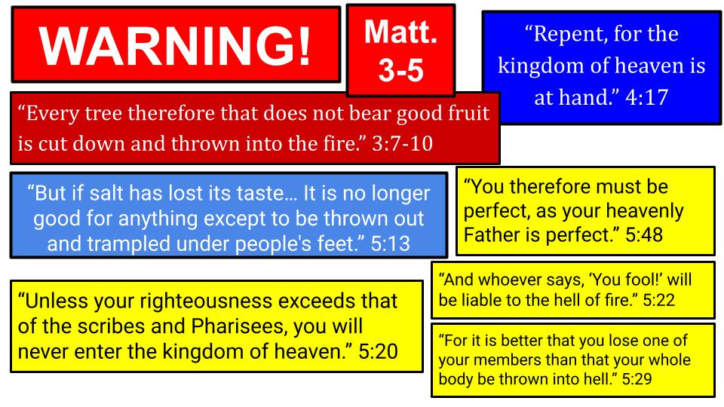
To repent is to turn away. It is to recognize that you have been going the wrong way and to pull a complete 180. Repentance is a total change of mind and heart. Jesus describes it as a change of CITIZENSHIP. You recognize that a new kingdom has appeared in Christ the King, and you trade your old allegiance for a new one.

The call to repentance itself is a stern warning. Jesus picks up the language of John the Baptist, who, back in chapter 3, warned about trees that don’t bear good fruit and are chopped down and burned up. He’ll come back to that same image in Matthew 7 and again in John 15. Look at the other warnings in Matthew 5, the opening of the Sermon on the Mount.
- If salt has lost its taste, what good is it? It will simply be thrown away and trampled like any other small rocks.
- In the section about righteousness that deals with anger, lust, divorce, revenge and vows, Jesus sums it up saying the only way to enter His kingdom is if your righteousness exceeds the religious leaders who were notorious for their impossible standards.
- To conclude chapter 5 Jesus says the full requirement for the kingdom of heaven is nothing short of PERFECTION. He updates the call of Leviticus 19 to be HOLY as God is holy and says the fulfillment of that command is perfect righteousness.
- And twice in that righteousness section Jesus said it’s better to gouge out an eye or cut off your hand and go through life as a beggar and a cripple than to risk being thrown into hell.
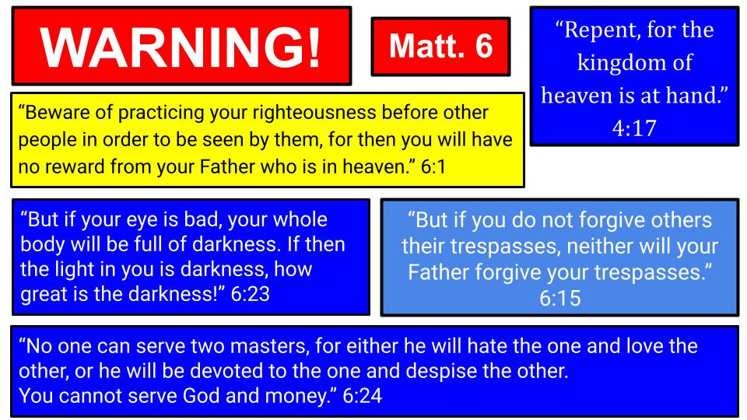
Then we turn to Matthew 6 and the heart of the SOTM. Jesus continues to talk about practicing righteousness but warns of what not to do: don’t practice the disciplines of giving, praying and fasting to impress people but only for God who sees what you do in secret.

After the Lord’s Prayer, which includes the key petition to ask God to forgive us our debts even AS we forgive our debtors, immediately after the prayer comes the promise and the warning. The promise is if you DO forgive others, God will forgive you. But don’t miss the serious warning: if you do NOT forgive others, God will NOT forgive you.

Then after teaching about storing treasure in heaven not on earth where it won’t last, Jesus concludes with this warning about your EYE. What do we focus on? What do we look at? Is it all earthly things? Are we obsessed with the things of this world? Then we are not letting the light of eternity and the light of God into our hearts. Then the “light” within us isn’t light at all, it is the darkness of this world.

In the end, Jesus concludes, it’s a matter of allegiance and worship. You can’t serve two masters; you must choose one or another. Jesus or yourself. His kingdom of this world. God or money. You can’t have two. Just one.
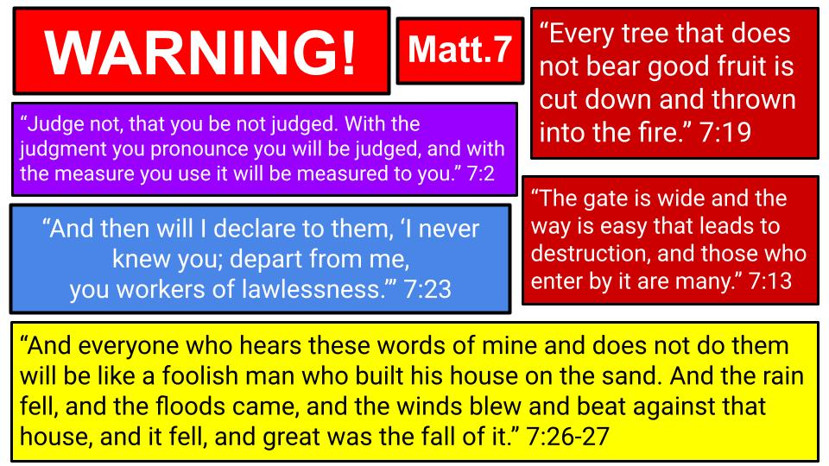
Then, in the home stretch, the final chapter of the SOTM, we get even more warnings, even scarier ones. First, don’t judge others since you have giant logs sticking out of your eye, so you can’t see clearly, and the way you judge others is how YOU will be judged. So, it’s best not to do it. Then Jesus comes back to John the Baptist’s good tree v. bad tree analogy and repeats the baptizer’s warning that bad trees get chopped down and burned up.

Jesus adds a warning about a small gate and narrow path that leads to life, as opposed to the large gate and the broad road that leads to DESTRUCTION. Let’s not miss the point Jesus makes here that MANY people choose the larger, easier path and refuse to bend the knee to Him in humility in order to enter His kingdom. Remember the first beatitude: only those who are POOR IN SPIRIT will inherit the kingdom of heaven. That narrow gate is the gate of humility and repentance. And few find it; few choose it.

Finally, Jesus closes the whole sermon with a memorable and terrifying dyad of warnings. First he describes those who apparently served him: casting out demons, doing miracles and preaching in his name, but they never actually knew Him personally so He throws them out. Then He talks about two builders: a wise and a foolish one. The wise builder sets his house on a firm foundation so it stands up to the storms of life. The foolish builder ignores that little step about a foundation and builds his house on the sand, wanting that ocean front view. But a house without a foundation will collapse in the first gust of wind. Jesus makes it clear the difference between the two people is whether they HEAR AND OBEY His teaching or they do not. That is the only firm foundation for this life and for eternity: hearing the message of Jesus and committing to Him in obedient faith.

Do you feel the force of these repeated warnings in Jesus’ message here? All of these warnings serve as strong exhortations to REPENT. Let go of this world, turn away from the path you are on, and follow Jesus in personal faith, if you want to be a citizen of the kingdom of heaven. If you don’t listen to Jesus’ message and you don’t commit to follow Him, you’ll miss that opportunity and be consigned to eternal darkness. You’ll be like that bad tree that doesn’t produce fruit and is chopped down and burned up.

Here is how Paul sums up this calling in Philippians 2.

“Therefore, my beloved, as you have always obeyed, so now, not only as in my presence but much more in my absence, work out your own salvation with fear and trembling.” Philippians 2:12

There are two meanings to that phrase “work out your own salvation.” First, it means “work it out,”: be sure of your salvation. Don’t assume. Don’t take it for granted. Do the work. Take it seriously. Fear and trembling. Nothing is more important than this. Eternity is at stake. The second meaning is “work out of it”: for those who are truly saved, don’t neglect your works. Practice your righteousness. Not to earn salvation but because you ARE saved. You ARE salt and light for Jesus. So be salty. Shine the light. Very similar to the warning in James that “faith without works is dead.” Real faith produces real works. A life that doesn’t bear the fruit of love, joy, peace, and patience is not the life of a follower of Jesus.

“Work it out.” That’s our message for today. BE SURE of your salvation. Don’t assume you’re all good because you grew up in church or said a little prayer one day. Look at the fruit. It’s been said, “If you were accused of being a Christian, would there be enough evidence to convict you?”

Today, we will see five signs of a true Christian in Matthew 7. If these five describe you, I hope it will be encouraging to you. If you don’t see these five signs, let this message from the apostle Paul challenge you to work it out this week. Pray for ears to hear the message of Jesus and a heart ready to respond.

Five Signs that you are Really Saved:
- (G)race: You Forgive people, you don’t Judge them
“Judge not, that you be not judged. For with the judgment you pronounce you will be judged, and with the measure you use it will be measured to you.” Matthew 7:1-2

Who are we to judge other people? The speck in someone’s eye seems so obvious to you, but somehow you don’t notice the giant log in your own eye. That attitude or word of judgment, whether out loud or just in your heart, is being filed away to be used in your judgment. So don’t do it. Don’t judge. Instead, forgive. That’s where the Lord’s Prayer takes us: “Forgive us our debts as we forgive our debtors.”

Five Signs that you are Really Saved:
- (G)race: You Forgive people, you don’t Judge them
“For if you forgive others their trespasses, your heavenly Father will also forgive you.” Matthew 6:14

As those who have been forgiven a lifetime of sin, the natural response to that kind of grace is to extend the same grace to others. Even our enemies, we are called to LOVE. Don’t repay evil for evil but turn the other cheek. Pray for those who persecute you. Say, as Jesus did, “Father, forgive them, they don’t know what they are doing.”

So that’s the first sign that you are a true follower of Jesus – you have been marked by grace. You have been forgiven much, so you love much. You have experienced grace so you joyfully share grace with others. Another word for this first one is HUMILITY. Go back to the first beatitude.

Five Signs that you are Really Saved:
- (G)race: You Forgive people, you don’t Judge them
“Blessed are the poor in spirit, for theirs is the kingdom of heaven.” Matthew 5:3

The rich in spirit, the confident and arrogant ones, don’t think they need grace or forgiveness, so they judge people. But the poor in spirit know how much they need God’s grace and in that humility they don’t judge other people but humbly extend grace to them.

The second sign of true faith in Jesus is similar.
Five Signs that you are Really Saved:
- (R)epentance: You are more Aware of your own sin than of the sins of others
“Why do you see the speck that is in your brother's eye, but do not notice the log that is in your own eye?” Matthew 7:3

The person who has been transformed by the grace of Jesus is much more aware of their own sin than they are of the sins of others. Humility is the cornerstone of their character. Repentance is not a one time event, but a daily, continual experience. Yes, you know Jesus has removed the log from your eye, but you still know that other logs are there. This one coincides with the second beatitude.

Five Signs that you are Really Saved:
- (R)epentance: You are more Aware of your own sin than of the sins of others
“Blessed are those who mourn, for they shall be comforted.” Matthew 5:4

Spiritual mourning is not general sadness, but tangible repentance. It is not generally turning from the things of this world, but practical repentance. It is confessing and turning away from PARTICULAR SINS. Those are the ones who will experience the comfort of complete forgiveness: the ones who are grieved by the depth and extent of their sin. They know the cost of that forgiveness: that it cost Jesus everything as He hung on that cross.

When you look back on the story of your life, are you more aware of your own sin or of the sins of others against you? It’s helpful and can be enlightening to recognize how others have harmed you. But are you also aware of the unhealthy ways you responded to that suffering? Have you taken responsibility for those responses?

There is a powerful moment in Celebrate Recovery, the Christian 12 step process, where you draw a line down a sheet of paper and recognize the bad things that happened to you on the left side but then also note the sinful ways you responded. That way you can ask God to help you forgive and let go of the left side things that were not your fault, and you can confess and ask God to forgive YOU for the right side things that WERE your fault. Interestingly, that step 4 in the 12 steps is where 80% of people who start Celebrate Recovery drop out. It is painful to repent. It takes courage to honestly assess your life and to acknowledge the many ways you failed.

But that is one of the clearest signs that you really have repented and trusted in Jesus: you KNOW your own sin. You’ve seen it and turned away from it. You’ve brought it to the cross and left it there. You don’t continue to carry it like heavy rocks in the backpack of your history.

What about you? Are you a person of grace? Have you clearly and specifically repented and turned away from your sin? Can you remember the time that you called on Jesus to save you? Maybe not the exact date and time, but the period of time that you became aware of your sin and heard about Jesus, asking Him to forgive you and change you.

Five Signs that you are Really Saved:
- (A)ssurance: You know God as your Father and trust in His goodness
“If you then, who are evil, know how to give good gifts to your children, how much more will your Father who is in heaven give good things to those who ask him!” Matthew 7:11

A true follower of Jesus develops the habit of prayer to our Father in heaven. You grow into a familiar friendship, a true relationship with God as your Father. The Lord’s Prayer teaches this to us, to regularly pray, “Our Father in heaven.” In the middle of that prayer is the humble request, “Give us this day our daily bread.” And here in chapter 7 Jesus expands on that to call us to Ask, Seek and Knock – to come to our Father in heaven seeking His kingdom first and asking Him for what we need to best honor and serve Him.

If we, as fallible human beings can give good gifts to our children, how much more should we trust our Father in heaven to know what we need and give us our daily bread? Romans 8 expresses this clearly and beautifully:

Five Signs that you are Really Saved:
- (A)ssurance: You know God as your Father and trust in His goodness
“For you did not receive the spirit of slavery to fall back into fear, but you have received the Spirit of adoption as sons, by whom we cry, ‘Abba! Father!’ The Spirit himself bears witness with our spirit that we are children of God.” Romans 8:15-16

Yes, we need to work out our salvation in fear and trembling, but one of the signs that you have worked it out is that the perfect love of God the Father drives out the fear of condemnation. When the Holy Spirit comes into the heart of the sinner who repents and believes in Jesus, He brings a powerful ASSURANCE of salvation. As those who are sealed with the Spirit of God, we KNOW that we belong to God. The Holy Spirit Himself makes this clear in the inner being of the true believer. John says it this way in his letter.

- (A)ssurance: You know God as your Father and trust in His goodness
  - You have a personal relationship with Jesus
“Whoever has the Son has life; whoever does not have the Son of God does not have life. I write these things to you who believe in the name of the Son of God, that you may know that you have eternal life.” 1 John 5:12-13

One of the main purposes of Scripture is to give this deep and personal assurance to those who truly know God and have been adopted into His family. How do you know that you really belong to Jesus by faith? You just know. It’s a thing older people say about being in love and it’s true of finding that one person you’re supposed to be with. It’s also true of your relationship with the Lord Jesus. When you know. You know. If you don’t know, then it’s time to go back to that fear and trembling and work it out. In the end, it all comes down to whether you know Jesus and He knows you.

- (A)ssurance: You know God as your Father and trust in His goodness
  - You have a personal relationship with Jesus
“On that day many will say to me, ‘Lord, Lord, did we not prophesy in your name, and cast out demons in your name, and do many mighty works in your name?’ And then will I declare to them, ‘I never knew you; depart from me, you workers of lawlessness.’” Matthew 7:22-23

In the end, it’s not about what a person DID for Jesus, it’s about whether you have come into a personal relationship with Jesus. You know Him, and more importantly, He knows you. Another analogy Jesus uses is of a wedding feast. When Jesus comes back it will be like a groom coming to celebrate with his bride. If you show up for a wedding and the bride and groom don’t know you, they will throw you out as wedding crashers. Jesus says it will be like that on the last day.

And don’t miss the warning here that this will be true for MANY people. They even know to call Him LORD. They appeared to really be serving Him. But in the end they were serving their own agendas and didn’t really know Him.

Three signs of true faith: grace, repentance, assurance. Two more.

Five Signs that you are Really Saved:
- (C)ompassion: You are known for your Love and you know it only comes from Jesus
“Every tree that does not bear good fruit is cut down and thrown into the fire. Thus you will recognize them by their fruits.” Matthew 7:19-20
Galatians 5 describes 9 fruits of the Spirit, but Jesus focused in on LOVE as the primary one. “By this all people will know you are my disciples, if you LOVE one another.” Jesus warns his disciples to watch out for false teachers, wolves that will try to sneak in among the sheep. He makes it clear that the way to identify fakes is “by their fruit.” Far from being loving to others, they will be all about their own glory and their own power, their own desires.

The loving person will sacrifice their own desires, and LIKE JESUS, will serve others. And they will be fully aware that anything good that comes from their life is from the Lord, not from them. Jesus makes this clear in John 15.

Five Signs that you are Really Saved:
- (C)ompassion: You are known for your Love and you know it only comes from Jesus
“I am the vine; you are the branches. Whoever abides in me and I in him, he it is that bears much fruit, for apart from me you can do nothing.” John 15:5

The only way anyone can bear good fruit for the Lord is by remaining in close relationship with Him. Abide. Dwell. Remain. Walk with Him. Fruit is an illustration of dependence. How does fruit grow on a tree or a vine? Only as it draws from the trunk of the tree or from the main vine! One more sign of true saving faith.

Five Signs that you are Really Saved:
- (E)ndurance: You obey God’s Word and bear the fruit of a changed life
“You will recognize them by their fruits. Are grapes gathered from thornbushes, or figs from thistles? So, every healthy tree bears good fruit, but the diseased tree bears bad fruit.” Matthew 7:16-17

False teachers will become obvious by their lack of love and their selfish motives. Unfortunately, there are plenty of examples of this in the church today. The more famous a preacher or leader becomes, the more likely he or she is to fall into visible sin. “Pride does indeed come before a fall.” Thankfully, the opposite is also true. Genuine faith and commitment to Jesus as Lord will produce the fruit of love, joy, peace, and endurance.

Healthy trees produce good fruit. Diseased trees produce bad fruit or no fruit. I like to use the illustration of a cup of water. When you’re shaken by hard circumstances, what is inside of you comes out. If it’s clean water, that will come out. If it’s coffee or acid, that will come out. We can’t blame the situation or another person. If it comes out, it’s what was in there. “Out of the overflow of the heart,” Jesus said, “The mouth speaks.”

So here is our summary for today.

Five Signs that you are Really Saved:
- (G)race: You Forgive people, you Don’t Judge them
- (R)epentance: You are more Aware of your own sin than of the sins of others
- (A)ssurance: You know God as your Father and trust in His goodness
  - You have a personal relationship with Jesus
- (C)ompassion: You are known for your Love and you know it only comes from Jesus
- (E)ndurance: You obey God’s Word and bear the fruit of a changed life

When you look at your life, do you see this kind of fruit? We had a magnolia tree in front of our house. It was never super healthy, but it would have those nice big white flowers at least once a year. But this year, it dried up, and all the leaves fell off. My neighbor across the street, who gives us avocados, came over one day and trimmed off some of the dead branches. He shook his head and said, “No se si va a resucitar.” I don’t know if it’s going to come back. I said, “Probably not. It looks dead.” He shook his head in agreement and said, “Se murió.” That’s a definitive statement. “It has died.”

We gave it another couple of months. But when my parents were in town, Dad took the chainsaw and chopped it down. So “se murió” became “se fue.” It has died. It is gone.

But a good tree, that is much better taken care of than our magnolia, bears fruit and continues to.

Do you see these signs of true faith in your life?
- Grace - you know how much you have been forgiven, so you joyfully forgive others, rather than judging them.
- Repentance - you are more aware of your own sin than you are of the sins of others.
- Assurance - you know the love of God as your Father and of Jesus as your Savior. You feel the presence of the Holy Spirit and have that Blessed Assurance that Jesus is yours and you are his.
- Compassion - you aren’t perfect, but you do love people and are growing in compassion.
- Endurance - you not only know God’s Word and love to read it, but you obey God’s Word and persevere in doing so, even in times of hardship.

Just as we have possessions that are precious to us and we take extra care with them. Just as we have people, like a newborn baby, that we are extra careful with. So you have our most precious thing – your eternal soul. Just one chapter later, in Matthew 8, Jesus says this:

“And calling the crowd to him with his disciples, he said to them, ‘If anyone would come after me, let him deny himself and take up his cross and follow me. For whoever would save his life will lose it, but whoever loses his life for my sake and the gospel's will save it. For what does it profit a man to gain the whole world and forfeit his soul? For what can a man give in return for his soul?’” Matthew 8:34-37

To save your life, you must lose it. You must repent and turn away from everything in this world, including your desires and plans. You must deny yourself, take up your cross, and surrender your life to Jesus. That is true saving faith. The alternative is to try to hang onto your life in the hopes of gaining this world. But even if you do get all the money and fame and success in the world, what if it costs you your eternal soul? What then can you give in exchange for your soul?

Work out your salvation with fear and trembling. BE SURE you know Jesus and He knows you. Let’s pray and give thanks for the blessed assurance that can be ours when we do truly know Jesus.

