The Law of Love
Matthew 7:12-14

One of the biggest questions in understanding the Bible is: what is the relationship of the Old Testament to the New Testament? Did Jesus’ teaching, his death and resurrection and the writing of the NT make the OT completely irrelevant? Obviously, there is no temple anymore in Jerusalem, so disciples of Jesus could make a pilgrimage to Israel to celebrate the Passover, but even if we bought a lamb, we wouldn’t have a place or a priest to handle the sacrifice for us. And those two examples - the Passover and the sacrifice system – have clearly been fulfilled in Jesus making the OT way obsolete.
- We do celebrate the Passover, but now it’s the Lord’s Supper and the bread and wine have a new meaning in Jesus.
- Same thing with animal sacrifices. Since Jesus is the Lamb of God who takes away the sin of the world, all other sacrifices are unnecessary because of the Lord’s once for all sacrifice for us.

Still, in Matthew 5 we have this clear and significant statement from the Lord:

“Do not think that I have come to abolish the Law or the Prophets; I have not come to abolish them but to fulfill them. For truly, I say to you, until heaven and earth pass away, not an iota, not a dot, will pass from the Law until all is accomplished.” Matthew 5:17-18

As far as I can see, heaven and earth are still here and even though Jesus' death and resurrection accomplished a complete atonement, ALL has not yet been accomplished until Jesus comes back and makes all things new in the new heaven and new earth. Therefore all those iotas and dots in the Old Testament have not passed away. They have not been abolished. Jesus did not come to get rid of them but rather to fill them full; to bring the Law of Moses and the prophets to their target and goal. And what is that target?

“But I say to you, Love your enemies and pray for those who persecute you… You therefore must be perfect, as your heavenly Father is perfect.” Matthew 5:44,48
“So whatever you wish that others would do to you, do also to them, for this is the Law and the Prophets.” Matthew 7:12

The fulfillment of the Old Testament is LOVE. True, from the heart, love. And not just for your friends and family who love you back – but even for your enemies, and for strangers and widows and orphans who can’t give you anything back. Treat others the way YOU want to be treated. That sums up the OT. That IS the Law and the Prophets. Listen to Isaiah 58, a rebuke of the religious activity of the Jews:

“Is not this the fast that I choose: to loose the bonds of wickedness, to undo the straps of the yoke, to let the oppressed go free, and to break every yoke? Is it not to share your bread with the hungry and bring the homeless poor into your house; when you see the naked, to cover him, and not to hide yourself from your own flesh?” Isaiah 58:6-7

Doesn’t this sound a lot like Matthew 25 and the final judgment? “I was hungry and you gave me something to eat. I was thirsty and you gave me something to drink. I was sick or in prison and you visited me… I was a stranger and you invited me in.” It also sounds like Isaiah 61, which Jesus announced as his mission statement in Luke 4, early in his ministry.

“The Spirit of the Lord God is upon me, because the Lord has anointed me to bring good news to the poor; he has sent me to bind up the brokenhearted, to proclaim liberty to the captives, and the opening of the prison to those who are bound; to proclaim the year of the Lord's favor…” Isaiah 61:1-2

The good news the Messiah brought was for the poor, the broken, the enslaved, the bound. The religious ones who knew the OT best did not hear Jesus’ message as good news but instead resisted it and rejected Him every step of the way. “It is not the healthy who need a doctor, but the sick.” Jesus did not come to call the righteous, but “sinners to repentance.” Only the poor in spirit will hear the gospel and receive it with gratitude and joy. The proud, confident and arrogant who don’t think they need anything from God will reject this message and the Lord who offers it. In the process they will miss the year of the Lord’s favor.

But those who are humble and turn away from this world to trust in Jesus and follow Him will experience all the blessings of the Lord’s favor. They will be adopted as children of God, secure in His family forever. This short passage in Matthew 7 shows us three PRACTICES of these children of God. First:

Three Practices of God’s Children:
- Pray in Faith
“If you then, who are evil, know how to give good gifts to your children, how much more will your Father who is in heaven give good things to those who ask him!” Matthew 7:11

As Jesus taught in the Lord’s Prayer, we call on His Name, asking together for OUR daily bread. And we saw last week that we build kingdom community by praying together, trusting in the Father’s love together. We ASK, SEEK, AND KNOCK. We ask the Father for the things that we need and that are in service to His kingdom. We seek His kingdom first, prioritizing and pursuing what matters to Jesus. And above all that means LOVE. We love our neighbors, even our enemies who oppose us. We live like Jesus did, and that is the way of the cross: sacrificial love in service to others.

What are you praying for right now? What are you asking the Father for in Jesus’ Name? What are you seeking to advance the Kingdom of heaven? What doors are you knocking on to see if they open? Are they for your own comforts and desires or for the kingdom of Jesus? Are you trying to store up more treasure on earth or truly seeking to store up treasure in heaven?

The first regular practice of a child of God is that we pray in faith. We trust in our Father in heaven to not only give us our daily bread but to give us EVERYTHING we need to serve Him and build up His kingdom. Second practice of a child of God:

Three Practices of God’s Children:
- Practice the Law of Love
“So whatever you wish that others would do to you, do also to them, for this is the Law and the Prophets.” Matthew 7:12

Jesus did not come to “abolish the Law and the Prophets but to fulfill them” – to fill them full; to accomplish their whole purpose and enable His followers to really love God and love others. Later, Jesus would say these two commands are the greatest in the whole Old Testament: Love God, love your neighbor. That sums it up. Here, Jesus sums it all up in one command: the Golden Rule. “Do to others as you wish they would do to you.”
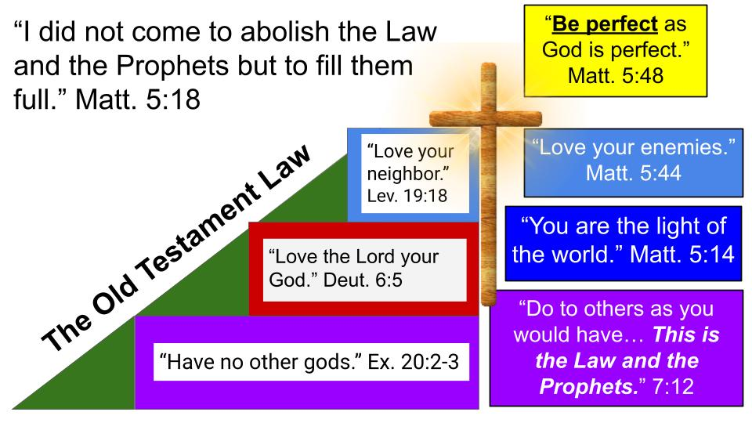
This IS the Law and the Prophets. Not only does it sum up the OT, it IS the Old Testament in brief summary form. Don’t just love your neighbor, love your enemies. Don’t just keep the 10 commandments, be PERFECT, like your Father in heaven. Bring the light of God’s holiness and love to all the nations.
What does that love look like? It looks like JESUS. Sacrifice. Putting others first. Out of heartfelt love for God and true worship of Him alone, let His love flow through you to serve others, especially the most vulnerable: the poor, the immigrant, the orphans and widows. Paul says it this way in Philippians 2.

Three Practices of God’s Children:
- Practice the Law of Love
“Do nothing from selfish ambition or conceit, but in humility count others more significant than yourselves. Let each of you look not only to his own interests, but also to the interests of others.” Philippians 2:3-4

Humility is the cardinal virtue. It is the virtue that enables all the other virtues. Humility is what allows us to actually BELIEVE that other people are more important than we are. Pride believes the opposite: it firmly believes that YOU are more important, therefore your needs and desires are more important than the preferences of others. So pride blocks all other virtues, especially love. Hence the command to “do NOTHING from selfish ambition.” Rather, be motivated by humility so you can see the interests of others and commit yourself to serving them. As Jesus did.

Three Practices of God’s Children:
- Practice the Law of Love
“Have this mind among yourselves, which is yours in Christ Jesus, who, though he was in the form of God, did not count equality with God a thing to be grasped, but emptied himself, by taking the form of a servant, being born in the likeness of men.” Philippians 2:5-7

Don’t miss the details here. We are commanded to HAVE this mind. But we are told that this mind is already ours in Christ. What mind or mindset or attitude are we to have? The mindset of a SERVANT. The most exalted One humbled Himself. The most glorious One emptied Himself and took the lowest place, going all the way to death on a cross. The most humiliating and painful death imaginable.

And back in Matthew 7, remember, this sums up the whole Old Testament. This IS the Law and the Prophets. God’s whole desire for His people to be holy, to be set apart from all other nations as belonging to Him. All of that is summed up in the word LOVE. Servant-minded, sacrificial love. “Greater love has no one than this, that he lay down his life for a friend.”

Three Practices of God’s Children:
- Practice the Law of Love
“So whatever you wish that others would do to you, do also to them, for this is the Law and the Prophets.” Matthew 7:12

What does the practice of LOVE look like for you right now? For whom is God calling you to lay down your life? What sacrifices are you making? How are you serving others? How are you placing the needs of others ahead of your own?

Let’s pause to PRAY. Heavenly Father, we humbly ASK you to help us love others. Help us to place the needs and desires of others ahead of our own. Strengthen us to serve, to lay down our lives. Enable us to do unto others what we would have them do unto us.

This is what God did for us. This is what Jesus’ life looked like. He prayed in Faith, trusting completely in the Father. He practiced the Law of love, placing our needs ahead of His own. One more practice of a child of God.

Three Practices of God’s Children:
- Persevere through Adversity
“Enter by the narrow gate. For the gate is wide and the way is easy that leads to destruction, and those who enter by it are many.” Matthew 7:13

The way of a Christ follower is against the grain, against the primary flow of traffic. Most people choose the easy path, the wide gate. Not to serve others, but to serve themselves. Of course that’s the natural path. Exalt yourself. Serve yourself. Follow your own desires. Ignore or downplay the needs of others. Seek your own way. Do what is right in your own eyes. It’s the way most people go. It’s the wide gate.

But notice where it leads: to destruction. Proverbs tells us, “There is a way that seems right to a man but in the end it leads only to death.” One of the prominent examples of this in Proverbs is the “forbidden woman,” the adulteress. She may look attractive to the young, foolish man, but eventually her husband will come home, and when he does, what will he do with the young fool who has been with his wife? The jealous husband will chase down that miscreant and it will not go well for the adulterer.

But the narrow gate is the one that leads to life.

Three Practices of God’s Children:
- Persevere through Adversity
“For the gate is narrow and the way is hard that leads to life, and those who find it are few.” Matthew 7:14

Let’s not miss the warning in this passage. MANY stumble blindly to destruction just following the crowd. Only a FEW find the narrow gate to life. The first beatitude already told us that the gate to life and blessing is for those who are poor in spirit. You must enter on your knees. It’s the gate called humility. Felt need. Calling on Jesus to be saved. Anyone who is too proud to admit their need will miss this narrow gate. They will go right by on their way to destruction. Not just earthly death, but eternal death, suffering and condemnation.

So, let’s apply the law of LOVE, the Golden Rule, to a few different categories of people.

Three Practices of God’s Children:
- Practice the Law of Love
“So whatever you wish that others would do to you, do also to them, for this is the Law and the Prophets.” Matthew 7:12

- Put yourself in the situation of someone who has never once heard the name of Jesus.

They don’t even know about the large gate and the broad road. They don’t know they’re on a path to judgment and destruction. They’ve never heard of a way of salvation and eternal life.

If that was YOU and your loved ones, how would YOU want people to treat you? What would you want people to do for you? Would you want people to just leave you alone? Of course, you’d want people to be friendly to you, compassionate, not rude. But wouldn’t you want people to go out of their way to get this message to you? Wouldn’t you want them to make sacrifices in terms of finances and even take personal risks to bring the good news to you and your family.

It has been said, “The news is only good if it gets there in time.”

- Consider people who are drinking dirty water every day. They frequently get sick and their children are frequently sick. Some of their children even die due to preventable diseases from unfiltered water.
If that was your situation, what would you want people to do for you? Would you want comfortable Americans drinking 50 BILLION plastic water bottles every year to share some of that clean water with you? 136 million bottles of water EVERY DAY. 156 bottles of water per person per year. And that’s just in the U.S.

People who get Starbucks coffee every day spend anywhere from $1,000 per year and up to $5,000 if they have expensive tastes. If your 3-year-old was crying every day because of dirty water and your 5-year-old was in the hospital dying – both from totally preventable diseases – how would you want to be treated?

Who is ready to sign up for the next Filter of Hope trip?

- Imagine that you are a single mother, caring for 2 young children here in Tampa, working 2 jobs, and still not making ends meet.

You don’t have family in town, and the few friends you have are in worse shape than you, many of them with serious addictions to drugs and alcohol. So you can’t leave your kids with them. If that were your situation or the situation of your daughter, how would you want to be treated? What do you wish people would do for you or for your daughter?

Wouldn’t you want a phone number to call and people who would safely care for your children for a weekend or so? Wouldn’t you want someone to help you get a better job? Say you need a toddler bed for one of the kids and DCF has threatened to take both kids if you don’t get that bed in the next week.

This is what the ministry of Better Together and Safe Families is designed to address. PTL, we have ministries like this designed to help churches like ours get involved in situations like this. The Care Portal allows DCF workers to post needs like the toddler bed that registered churches can then see and sign up to take care of.

Those are just a few examples: someone who has never heard the name of Jesus; a family without clean water; a single mom who needs help with her kids. Imagine these other situations right here in Tampa:
- You’re a 15-year-old chained up in an attic, being abused every day, without any means of escape.
- You’re an 18-year-old just aging out of foster care, with nowhere to go, no idea what to do next, no path toward education or work.
- You’re a 30-year-old alcoholic who just can’t kick the habit. Every time you have tried, you have fallen right back off the wagon.
- You’re a religious person who goes to church pretty much every week, but it doesn’t give you hope; it fills you with guilt and burdens you with a sense of obligation, and you don’t know how to escape it. No one has ever explained to you what grace is all about, and you can’t imagine what it would feel like to be loved and accepted by anyone, certainly not by God.
- You’re married, with 3 kids, you work hard, and so does your wife, but you have over $50,000 in credit card debt and no idea how to even begin to pay it off. You’re trapped in the cycle of just making minimum payments so you can’t make any progress, and the stress is wearing on you, your marriage, and even your kids.
- You have serious cancer and are filled with fear about what will happen next. Your wife passed away two years ago, and you lost both parents and a brother in the last five years. You just wish you had someone to talk to, someone who could drive you to doctor’s appointments, someone to help you after surgery.

Imagine the neighbors who live right next to you, maybe behind you or across the street from you; maybe someone who sits next to you in class or at work. If you knew for sure that one or two of your closest neighbors was in one of these situations, would it change how you treat them this week? Would it change how you pray? Here is our summary for today:

Three Practices of God’s Children:
- Pray in faith  - Practice the Law of Love  - Persevere through Adversity | “So whatever you wish that others would do to you, do also to them, for this is the Law and the Prophets.” Matthew 7:12

After Jesus washed his disciples’ feet, he said, “I’ve set you an example so that you will do as I have done for you.” Then he told them about a New Command: LOVE ONE ANOTHER. That’s the summary. That’s the OT Law and the Prophets. Love. Do to others as you would have them do to you. “Don’t do anything from selfish ambition or empty conceit but in humility consider others better than yourself.” Don’t judge other people, you have too many huge chunks of wood stuck in your eyes, so don’t quibble about the specks in the eyes of other people.

The whole sermon on the mount presents the Jesus Way, an outline of His Kingdom truth and lifestyle. In the end this all boils down to one word: LOVE. As Jesus summarized later in his ministry: Love God and love your neighbor. Period. End of lesson. Just love. What does that look like practically? Doing for other people what you would have them do for you. Put yourself in their place.

Keith and Melody Green story – No Compromise book.

