The Commission
Matthew 28:16-20

I’d say the best war movie in the last twenty years is Hacksaw Ridge with Andrew Garfield. It’s very intense, so not for younger viewers, but it presents the true story of Desmond Doss who was a combat medic in WW2.
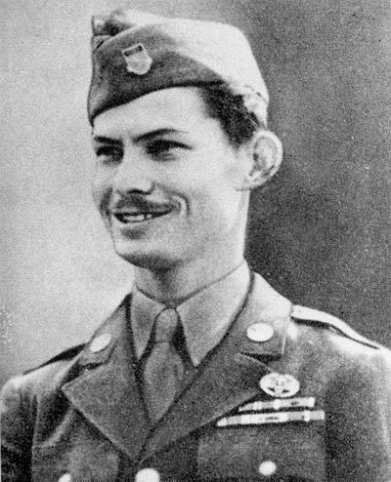
https://en.wikipedia.org/wiki/Desmond_Doss

Doss was a conscientious objector who refused to carry a weapon or participate in killing. But he felt called to contribute to the war effort and so was trained as a medic and joined the US Army to serve. He and his company were sent to a military objective in the Pacific called Hacksaw Ridge, where the US and the Japanese were in a back-and-forth deadlock. One would drive out the other, then get forced back again. It was a terrible, bloody combat zone.


As the US Army followed orders and pressed the attack yet again, many of the men were badly wounded and started calling for medics to keep them alive and drag them back to recovery tents. Doss was among the medics who went in, at great risk to their own lives, attending to the wounded soldiers and working together to lower them down the escarpment with ropes to the medics below.

The film exaggerates and changes some of the details of Desmond’s life but much of the story is accurate, especially the combat and risk. When all other medics had gone down the cliff, Doss remained above to get all living soldiers lowered down to the medical staff below. His prayer, as the night dragged on, was “Lord, help me get one more.”

The film ends with the real Desmond Doss remembering those terrifying moments and saying the words of that prayer, “Lord, help me get one more.”

If the rest of the movie doesn’t make you cry, that part with old Desmond is likely to.
There are two applications of this movie to our passage today. First, the US Army had an assignment; they had a mission to accomplish: to conquer Hacksaw Ridge. It wasn’t an easy mission. It was dangerous. Many had already tried and failed. But the mission from the Allied leaders was clear and the objective spelled out definitively: attack and conquer this particular ridge so the approach toward Tokyo could advance. A bombardment will fall at this hour of the morning. When the bombs begin to stop falling, the soldiers must start to climb the rope ladders and be prepared for their ground assault.

That was the task of the infantry. There was a corresponding task for the medics. Since heavy casualties were expected, the medics must be prepared to rush in to attend to the wounded right away and drag as many as they could to safety behind the front lines and lower them with ropes to the waiting medical staff below, who also had a clear assignment to stabilize the wounded and transport them to the medical tents well behind the front lines where the waiting doctors and nurses would do all they could to save the lives of every soldier who was wounded in the battle.

The key passage for our summer series on missions has been right here out of Matthew 28:

“And Jesus came and said to them, ‘All authority in heaven and on earth has been given to me. Go therefore and make disciples of all nations, baptizing them in[to] the name of the Father and of the Son and of the Holy Spirit.’” Matthew 28:18-19

Any soldier or medic in the US military would understand that orders from above him or her meant a mission was given and it was their job to fulfill that mission. It wasn’t up for debate or discussion. It was a task, it was a commission, and you obeyed the orders.

Look closely at these words from the Lord Jesus. His authority is not below the US President or any military leader in the US or anywhere else. His authority is OVER all people, all nations, all spiritual beings. All of the authority is HIS. Based on that indisputable fact, every follower of Jesus is commanded, commissioned to GO and make disciples of all nations. This isn’t debatable or up for discussion. It is a task, a clear and definitive commission. It is for us as followers of Jesus to obey; to carry out the orders of our Master and our King.

Let’s study this passage today, as we have heard from it multiple times already in our summer series. Since it is so important for us as those who have been trained to not just KNOW the teachings of Jesus but to OBEY them, it should be a passage we have memorized and actively apply every day. We are not like the foolish builder who heard the words of Jesus and did not put them into practice. We are like the wise builder who heard and DID the teachings of Jesus.

Today we will break this down into four parts of the command: why, what, how and who… Why obey? What do we obey? How do we obey? Who helps us obey? Let’s start, as the passage does, with the why.

Why obey the Great Commission?
- To Glorify Jesus – the Lord of all things
“Now the eleven disciples went to Galilee, to the mountain to which Jesus had directed them. And when they saw him they worshiped him, but some doubted.” Matthew 28:16-17

It’s so encouraging – to me – that this landmark passage starts with this verse. “They worship him, but some doubted.” Now, the 12 apostles were chosen to encourage people like us, from the first group on the shores of the Sea of Galilee. These were not the best and brightest in Israel in those days. In some ways they were the lowest and the dullest. Jesus kept saying, “Are you paying attention? Do you get it?” And they were like, “Huh, whuh. Huh?”

Even here, after Jesus they saw Jesus alive and right in front of them, “SOME DOUBTED.” In their defense, the exact chronology of the post-resurrection sightings of Jesus are a little hard to pin down. It’s possible at this point only a few of the women had seen Jesus face to face. Maybe for the group of men, this was their first encounter with the Risen Christ. So naturally, some doubted their own senses. Remember when they saw Jesus walking on water and some thought it was a ghost?

“Uh, fellas – are you starting to realize who I am? Pete, remember that little chat we had when I called you Satan? Still, you got the answer right, so could you maybe remember the lesson here and now? John, we get it – you won the footrace to the tomb and both you and Peter looked inside to see there was no BODY there. Come on. Can we get there? Two, plus two… equals… the Messiah, the Son of God, the One who came to take our sin and conquer death…”

Well, at least some of them bowed down to worship Jesus. Some were putting together that history had just changed. Their lives had just changed. Some, it would take a few more visits. A few more chats with the living Jesus. Thomas, for one, missed the first visit from Jesus in their locked house. He had to wait eight days for another visit. John writes about this in chapter 20 of his gospel.

Eight days later, his disciples were inside again, and Thomas was with them. Although the doors were locked, Jesus came and stood among them and said, “Peace be with you.” ²⁷ Then he said to Thomas, “Put your finger here, and see my hands; and put out your hand, and place it in my side. Do not disbelieve, but believe.” ²⁸ Thomas answered him, “My Lord and my God!” ²⁹ Jesus said to him, “Have you believed because you have seen me? Blessed are those who have not seen and yet have believed.” John 20:26-29

So was Thomas among those who “doubted” in Matthew 28? If he was there, then it’s pretty likely he was having a hard time believing what was going on. But consider the patience and love of Jesus to make this appearance knowing that Thomas and others would take time to register and believe what they were seeing.

Why obey the Great Commission?
- To Glorify Jesus – the Lord of all things
“Now the eleven disciples went to Galilee, to the mountain to which Jesus had directed them. And when they saw him they worshiped him, but some doubted.” Matthew 28:16-17

One by one, those disciples were beginning to realize who Jesus was and what it meant to be sent out by Him to share this incredible good news with the world. Have we begun to realize this life-changing and world-changing truth? Or are there still – right here in this room – those who are doubting?

Of course there are.

This is the roller coaster of the Christian life. We have seasons that we ride high on faith and times that we walk through dark valleys of doubt and fear. But one of the resources God gives us to help in those low times and strengthen us in every season, is the TRUTH about Jesus and how He is worthy to be worshiped, no matter what we are going through.

Why obey the great commission? It’s the same answer for why follow Jesus in the first place? Why trust in the Lord? Because of just that: because He is Lord. Back in Matthew 16, Jesus took the disciples to a place known for its worship of many gods and various local idols. And there, amongst many other places of worship he asked them “who do people say that I am,” then he made it personal:

- To Glorify Jesus – the Lord of all things
He said to them, “But who do you say that I am?” ¹⁶ Simon Peter replied, “You are the Christ, the Son of the living God.” ¹⁷ And Jesus answered him, “Blessed are you, Simon Bar-Jonah! For flesh and blood has not revealed this to you, but my Father who is in heaven.” Matthew 16:15-17

This should really encourage us as we seek to reach out here in our home town and around the world: only GOD can open the eyes of people and show them this truth about Jesus. It is not within our ability to do this, but it is our privilege to participate in this special work of God by sharing the message and opening God’s Word to those who, apart from that, are blind and deaf.

So why do we obey the great commission? It’s really very simple: because Jesus is Lord. That’s the summary message we announce: Jesus Christ is Lord. We share this news because it’s true. Because He is worthy. Because He lives. He rose from the dead.
It’s as simple as that. Why share? Why make disciples? Because the message is true. That’s the why. Now on to the WHAT. What does it look like to obey the Great Commission?

What is the Great Commission?
- Make Disciples of all nations
And Jesus came and said to them, “All authority in heaven and on earth has been given to me. Go therefore and make disciples of all nations.” Matthew 28:18-19

Because Jesus is Lord, because all authority belongs to Him, because He died and rose again, victorious over sin and death forever, we obey Him. And this is His command, His commission: Go and make disciples. Hopefully this passage is becoming familiar to us now after several weeks rehearsing it. But familiarity can confuse the point, or blind us to the clarity and simplicity of it.

The great commission is not to go and win converts. First of all, it’s not in our ability to win anyone over. Only God can open the eyes of the blind. Only He can open deaf ears and enable them to hear and understand this message of good news. But also, it’s not the assignment to go and share the message with as many people as possible.

This is a really important distinction. Jesus won some converts in his three years of ministry. But the main reason his ministry lasted and changed the world is that he made several dozen very committed DISCIPLES. It’s not that they were super geniuses. We went over that. Even after their three years with Jesus, even after all the miracles and signs and teachings, still seeing the Risen Jesus some doubted.

What is the Great Commission?
- Make Disciples of all nations
“Now when they saw the boldness of Peter and John, and perceived that they were uneducated, common men, they were astonished. And they recognized that they had been with Jesus.” Acts 4:13

But they had been with Jesus. They knew Him personally. Isn’t this a beautiful verse in Acts 4? Peter and John were not going to win the next spelling bee or run for office in Judea. But it was clear: they had spent a lot of time with Jesus. They saw how He did ministry. How He loved people. They felt His love for each of them.

There is a touching scene in season 3 of The Chosen where little James, the one who walks with a hunch and a cane, comes to Jesus individually. The disciples had all been sent out with power from the Lord to heal others and cast out demons. But here is sweet little James walking around still visibly NOT HEALED. He goes to Jesus and very humbly asks WHY.

And Jesus has this touching personal interaction with James explaining the special privilege it is for some of us to NOT be healed but still to glorify and trust in Him. Now, this is one part of the Chosen that the modern writers added in for the sake of drama. It’s not specifically in Scripture that one of the 12 had a deformity or an illness. Paul talks about a “thorn in the flesh” that God did not take away, so there is one Bible example of something like this. But it’s possible, probable even, that one or two or several of Jesus’ close followers had illnesses or problems that were not healed by Jesus. He clearly was ABLE to heal anyone, but what about the people He chose NOT to heal?

This is exactly the kind of thing the disciples of Jesus would have experienced for 3 years. And is part of what they would have passed on to others as they made disciples who also made disciples.

What is the Great Commission?
- Make Disciples of all nations
And Jesus came and said to them, “All authority in heaven and on earth has been given to me. Go therefore and make disciples of all nations.” Matthew 28:18-19

It really is as simple as that: make disciples. Why? Because Jesus is Lord. He has authority over all things. What do we do? We make disciples. HOW? How do we actually do it? Four parts to this one. They’re pretty simple because you already have the passage memorized. You just may not be totally clear on how the parts relate to each other. Here is the basic version we all know.
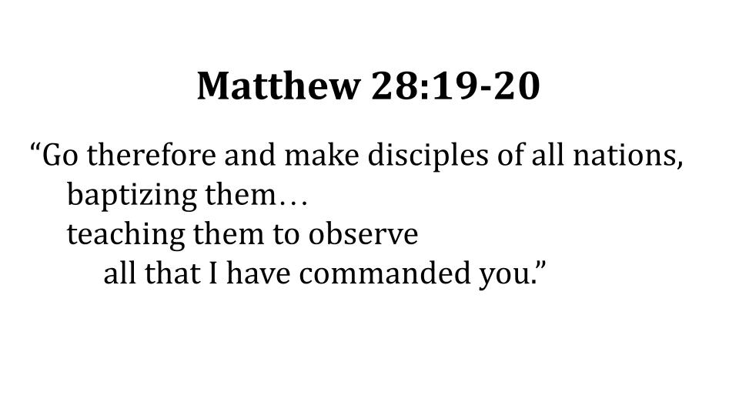
We’ve seen this enough to know the PRIMARY COMMAND is not to GO but to MAKE DISCIPLES. We just saw that in the what are we supposed to do section. Because Jesus is Lord, our mission is to make disciples. So let’s make the main verb a little more obvious.
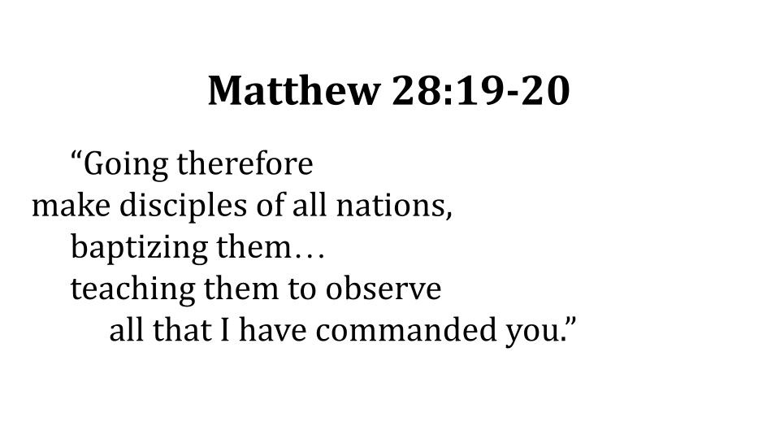

We put in some indents and made it clear that “going… baptizing and teaching…” are PARTICIPLES, not main verbs. They modify the main verb, the main command which is “make disciples.” One more slide just in case we have some folks who can’t remember any of their high school English grammar.

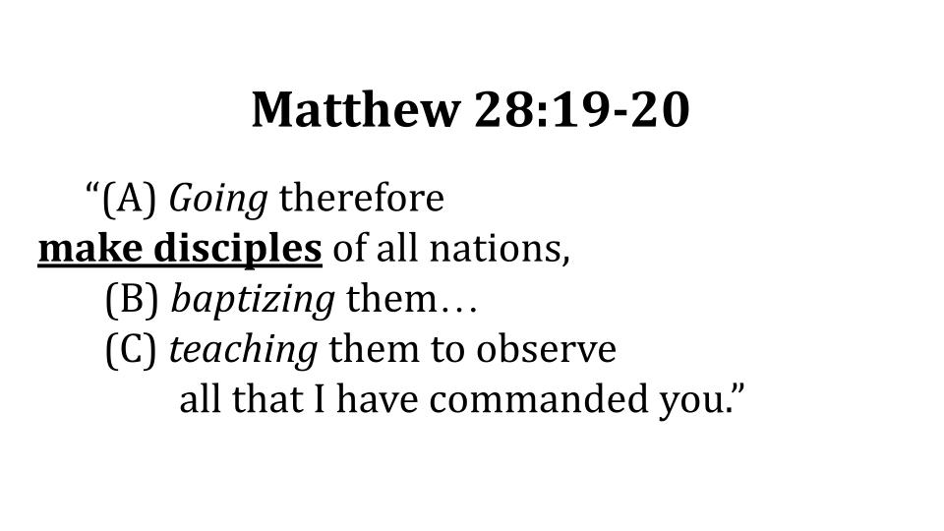

Three italicized participles show us HOW to make disciples. First, we have to GO. You won’t make disciples if you sit still. Second, we have to baptize believers. Third, we have to teach them how to obey. So let’s take these one at a time.

How to make disciples:
- Living on Mission for Jesus
“Going therefore make disciples of all nations.” Matthew 28:19

Another way to translate this is “As you go.” So it doesn’t mean all of us have to move to India or Afghanistan or Zimbabwe – though some of us should. We’ll get to that in a minute. But wherever we are, whatever we do, we should see it as a mission field where we can go ON MISSION for Jesus.

Are we living INTENTIONALLY, on purpose, or passively, without purpose?

Is the Great Commission part of your monthly, weekly and daily schedule? One pastor I knew said, “If it isn’t in your calendar, it doesn’t exist.” You might say you’re committed to exercise, but if you don’t schedule time and make plans to exercise, guess what? It doesn’t actually exist for you. You have to be intentional if you want to get fit. And the same is true with making disciples. It won’t just happen. You have to plan for it. Pray for it. Learn from others who are better at it. Just like with exercise. With work. With parenting. With marriage. Anything that is important needs to be approached with intentionality and planning. The same is true with making disciples.

GO. Jesus didn’t say “STAY.” He didn’t tell the disciples to SIT. Stand by. No. He said GO. Acts 1:8 gives the structure and plan for the whole book of Acts and Jesus’ marching orders for the disciples.

How to make disciples:
- Living on Mission for Jesus
“You will be my witnesses in Jerusalem and in all Judea and Samaria, and to the end of the earth.” Acts 1:8

Did the early church obey this command really well? Did they get out there right away to ALL Judea AND Samaria? What do you think? Yeah. They did about as well as we have.

So do you know what happened? Acts 8 happened.

How to make disciples:
- Living on Mission for Jesus
“And Saul approved of [Stephen’s] execution. And there arose on that day a great persecution against the church in Jerusalem, and they were all scattered throughout the regions of Judea and Samaria, except the apostles.” Acts 8:1

It’s almost like someone planned this. If you don’t obey Acts 1:8, you’ll get Acts 8:1. Where did those early believers get scattered to? Did you catch that detail? THROUGHOUT Judea and Samaria. All over. Everywhere they should have gone out of simple obedience, God scattered them through persecution.

What should we expect if we don’t obey the Great Commission now in our generation?

The way I read my New Testament, persecution and tribulation are coming for us regardless. But I betcha the fastest way to bring on persecution is to NOT GO but instead to sit around and live on mission for our own appetites. So that’s not OUR way. We are not those who sit down and disobey. We are those who get up and go – who live on mission for Jesus here and abroad. Second HOW of making disciples:

How to make disciples:
- Calling for Commitment to Jesus
“Going therefore make disciples of all nations, baptizing them in[to] the name of the Father…” Matthew 28:19

As we go and make disciples, we call people to repentance and faith in Jesus as symbolized by baptism. Baptism in water doesn’t save a person, it represents the salvation that happens when you profess your faith in the Lord Jesus. It’s like the wedding ring on your finger: you get that after you have said your vows. The vows are what make you married before God and others. The rings are what represent that union – a continuous, unbreakable bond.

The phrasing here is so beautiful as it relates to baptism and salvation: baptizing them IN the name of the Father, and we’ve noted the alternate or more literal translation inTO the Name. Isn’t that powerful? When you commit your heart and life to Jesus you are united with the Triune God – Father, Son and Holy Spirit. You ENTER or are IMMERSED in the Godhead. Which is why we practice baptism by immersion. Faith in Jesus connects you completely and eternally with Jesus and through Him with the Father and the Holy Spirit. Forever. Romans 6 is the key passage about baptism.

How to make disciples:
- Calling for Commitment to Jesus
“Do you not know that all of us who have been baptized into Christ Jesus were baptized into his death?” Romans 6:3

Union with Jesus is one of the great gospel truths in the Bible. Not only does the blood of Jesus cover and pay for our sin, His sacrifice makes it possible for sinners like us to be washed clean so we can be united with Him in loving, eternal relationship. Listen to how Romans 6 goes on.

How to make disciples:
- Calling for Commitment to Jesus
“For if we have been united with him in a death like his, we shall certainly be united with him in a resurrection like his.” Romans 6:5

In order to be united with Jesus in His resurrection, we have to first be united with Him in His death. We have to repent and bring our old self to the cross to die with Jesus so He can raise a new person to life. This is what it means to be BORN AGAIN and re-made as a new creation in Christ. But that’s what it takes to be set free from sin.

How to make disciples:
- Calling for Commitment to Jesus
“We know that our old self was crucified with him in order that the body of sin might be brought to nothing, so that we would no longer be enslaved to sin.” Romans 6:6

In order to be united with Jesus, to be set free from sin and saved from death, your old self has to die. You have to let go of that old, sinful YOU by bringing it to the cross of Jesus and asking Him to take it upon Himself. That’s what repentance is. As we call people to commitment to Jesus, it is important that we don’t just promise cheap grace. Yes, grace is free, but it was not cheap and still is not cheap.

Grace cost Jesus everything and it costs us everything to receive it. Jesus said, “Whoever tries to save their life will lose it, but whoever loses their life will save it.” It’s all or nothing. You give up your life and trade it for the life of Jesus, or you don’t get Jesus at all. This is why we don’t just try to win converts; we call people to full, all-in commitment to Jesus. “Repent and believe, and demonstrate that true belief through baptism.” Let’s go back to the Great Commission.

How to make disciples:
- Calling for Commitment to Jesus
“Going therefore make disciples of all nations, baptizing them in[to] the name of the Father and of the Son and of the Holy Spirit.” Matthew 28:19

Don’t miss the Trinitarian message here. Baptism illustrates not just union with Jesus but with God in all of His fullness. Father, Son and Holy Spirit. Again, you get all of God or none of Him. You are baptized IN the name of the Father, Son and Holy Spirit and really you are baptized INTO the Name.

Remember how important the NAME of God was to the Jewish people 2,000 years ago. What happened if you used God’s name in a casual or disrespectful way?

How to make disciples:
- Calling for Commitment to Jesus
“You shall not take the name of the Lord your God in vain, for the Lord will not hold him guiltless who takes his name in vain.” Exodus 20:7

The name of God was so sacred in ancient Israel that they wouldn’t even pronounce it out loud. Not even the priests would say the name of God, but would replace that name with the general word for Lord, Adonai. This is why the Jewish leaders were so offended by Jesus calling God his Father, which was making Himself equal with God.

To baptize people INTO the name of the Father, Son, and Holy Spirit is also a bold, even audacious step to take. Think about the gift of grace this is that we invite people into a relationship like this with God as our Father, with Jesus as our brother, with the Holy Spirit as our constant companion and guide.

How to make disciples:
- Calling for Commitment to Jesus
“Going therefore make disciples of all nations, baptizing them in[to] the name of the Father and of the Son and of the Holy Spirit.” Matthew 28:19

So making disciples means we GO - we live on mission for Jesus. It also means we call for commitment to Jesus as LORD, challenging people to repent, turning from their old life of sin and committing to follow Jesus as Lord. The third HOW of disciple-making comes right out of the second.

How to make disciples:
- Calling for Commitment to Jesus
“Going therefore make disciples of all nations, baptizing them… teaching them to observe all that I have commanded you…” Matthew 28:19-20

Here in the Great Commission, you can’t miss the reality that following Jesus involves serious commitment. To become a disciple, you have to die and rise with him through repentance and faith, symbolized in baptism. Then, as a disciple, your job is to learn ALL that Jesus commanded. All of it. And notice it’s not about teaching people to UNDERSTAND but to OBEY, to OBSERVE all that Jesus commanded. As we make disciples, we aim to make wise builders who hear the words of Jesus and do them; not foolish builders who hear and then do not do them. It’s not that obeying Jesus is what saves a person, but that obedience is the fruit – the evidence – that a person is saved.

So making disciples is about calling people to worship Jesus because He alone is worthy. Second, discipleship is about calling people to commit to Jesus because He is Savior and LORD. Jesus can only save a person who surrenders to Him as Lord. Don’t forget Romans 10:9-10 and the two things everyone must do to be saved: “If you confess with your mouth ‘Jesus is Lord’ and believe in your heart God raised him from the dead you will be saved.” Two steps are necessary: saying Jesus is Lord and believing He died for you and rose again. Basically it boils down to Savior and Lord. Is Jesus your Savior? Have you trusted in Him to wash away your sins? Is Jesus your Lord? Have you surrendered completely to Him as your Master and Teacher? When we call people to Jesus we call them to the only Savior and the only Lord. You can’t have Jesus as only one or the other.

How to make disciples:
- Training disciples to Make More Disciples of Jesus
“Going therefore make disciples of all nations, baptizing them… teaching them to observe all that I have commanded you…” Matthew 28:19-20

In these brief but important verses, it’s tragic how easy it is to miss this key principle. The Great Commission itself is to MAKE DISCIPLES. That involves going, baptizing, and teaching.
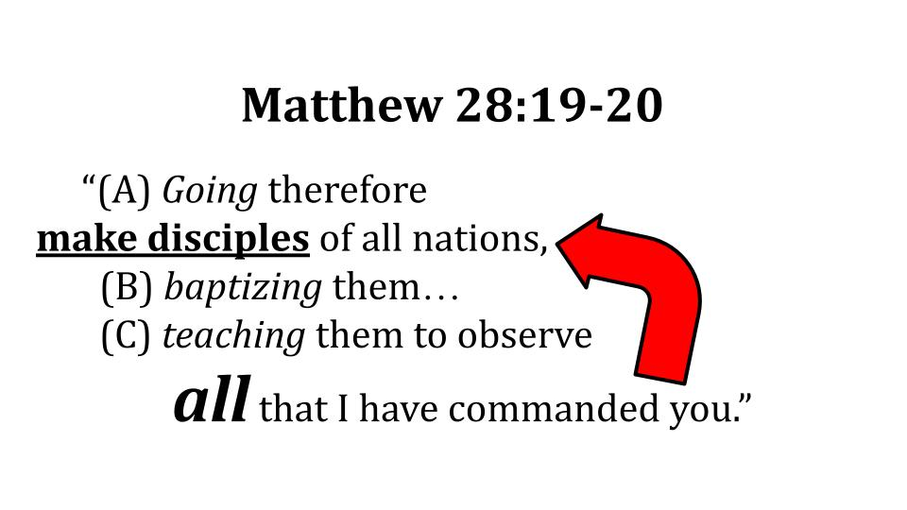
How can we think we are making disciples of Jesus who obey all of His teachings if we don’t train those disciples to obey the Great Commission itself?

If we are committed to making disciples, then we have to train our disciples to make other disciples who go on to make more disciples and so on.

Disciples make disciples who make disciples. It’s so simple it’s genius. One discipleship trainer said that the heart of the gospel is so simple it’s SNEEZABLE in a good way. Three words: “Jesus is Lord.” In the Roman Empire, the citizens were used to saying “Caesar is Lord.” So, this change, while dangerous to say out loud, was immediately understandable from the most uneducated peasant to the wealthiest bureaucrat.

Today that phrasing might be a little confusing, so we say “I believe in Jesus,” or “I follow Jesus,” or “I trust in Jesus.” Something along those lines.

Do you see the principle here? When can we rightly conclude that a DISCIPLE has been MADE? If this is our mission – to make disciples – isn’t it important to know when that mission has been accomplished?

If it was your mission to build houses wouldn’t you want to know when a house had been built? Or if your job was to make earrings, wouldn’t you need step by step instructions so you would know when a pair of earrings was finished and ready to sell? In either scenario, if you were training someone to work with you, wouldn’t it be important to show them each step of the process, all the way to the point where you could both say, “And THAT is a house that has been built!” or “Those are now earrings that can be sold!”

Do you see the problem with discipleship today? Many church-going believers see it this way:
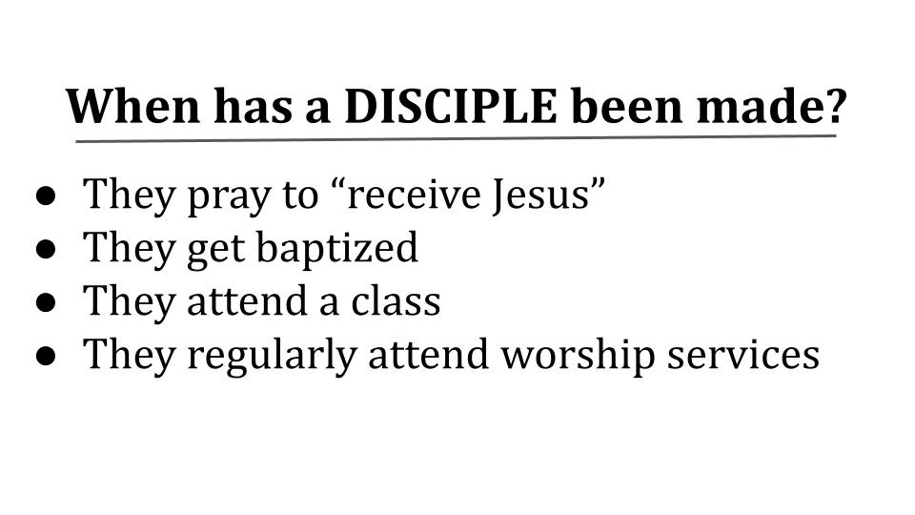
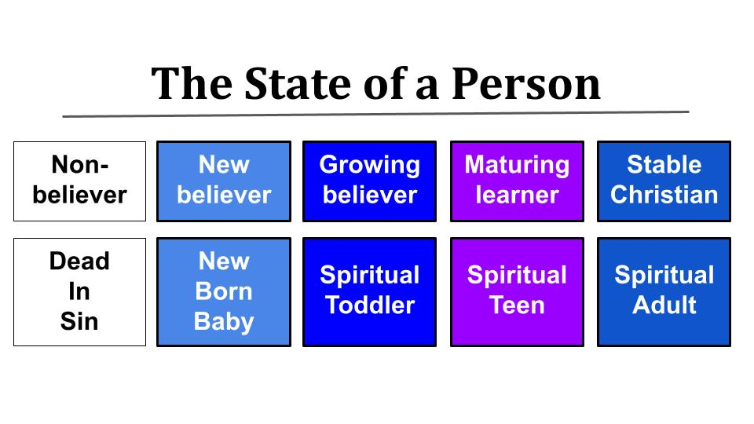
This is where the language of “receive Jesus” is problematic because it goes the wrong direction. You don’t ask Jesus into YOUR life, you beg Him to let you into HIS life. Trusting in Jesus and getting baptized are wonderful steps to take. Attending a class and making it a habit to attend worship services at a Bible teaching church should be very helpful to develop new patterns in life and start learning more about Jesus and the Christian life. I’m not saying these are bad things to do. I’m just saying that if a person does these things, he or she is not necessarily yet “a disciple.” A convert, maybe. A “believer,” hopefully. But has this person been trained to obey “all that Jesus commanded us”? Look at this progression in the state of a person.

First of all, we know from Ephesians 2 that a non-believer is outside of Christ and therefore DEAD in their sin. At the moment of salvation, when such a person puts their faith in Jesus, they become a new person, born again in Christ, united with God the Father, Son and Holy Spirit – praise the Lord! Most of us know not to leave a brand new baby out on the road, so a new believer should get some attention and at least get into a small group and start coming to worship services. Hopefully then the newborn baby will begin to grow into a spiritual toddler. You know those changes are coming along as the young Christian starts to feed him or herself and starts to toddle here and there on their own. You don’t expect that of a baby, but you do expect more from a toddler or preschooler. You expect a baby to still wear diapers and get messy sometimes, but you think a toddler or preschooler should eventually get potty trained and stop making messes all the time. And over time, with training, you hope and help that little one to grow through the primary school years into a spiritual teen who will start helping out a little around the house. They start to mature and read the Bible on their own. You see the progression, right? Eventually you hope this new believer grows up into a spiritual adult who doesn’t need you holding their hand anymore.

Now, does this progression feel COMPLETE to you? Or have you noticed what’s missing? Take a minute and just LOOK at this progression. It’s like looking at one of those pictures that you have to soften your eyes and look past it to see the 3D picture inside the picture. You’ll get it. “Teaching them to OBSERVE ALL that I have commanded you…” What does that ALL include? Oh, right! Making disciples! So the final stage of discipleship – is it spiritual adulthood?
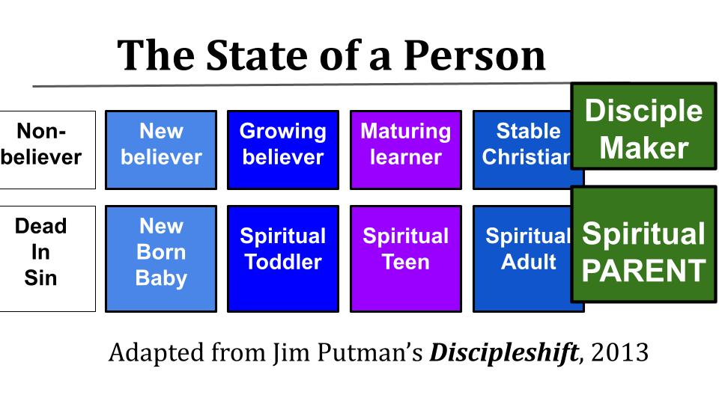
No. We know when someone has matured as a follower of Jesus not when they KNOW a lot about Jesus or about the Bible, but when they are actively making more disciples. They have become a spiritual PARENT; a disciple-maker.

Yes, this will look different in different stages of life and for different kinds of people. But maturity is not about adding more and more knowledge or more and more church activity to your schedule. When has a disciple been MADE? When that person starts actively and productively making MORE disciples.

Listen to the apostle Paul in 1 Corinthians 3.

“But I, brothers, could not address you as spiritual people, but as people of the flesh, as infants in Christ. I fed you with milk, not solid food, for you were not ready for it. And even now you are not yet ready, for you are still of the flesh. For while there is jealousy and strife among you, are you not of the flesh and behaving only in a human way?” 1 Corinthians 3:1-3

Paul called these church people in Corinth “infants in Christ.” He wasn’t denying their faith, just questioning their maturity. They couldn’t feed themselves, but needed someone else to come and feed them truth from the Bible. And instead of making more disciples they were fighting over which leader different groups were following. Instead of following the Holy Spirit they were following the flesh and fighting amongst one another. So there was no fruit there. No progress of building up the church. Building with cheap trash instead of lasting materials. The final judgment will reveal the quality of our building.

“Now if anyone builds on the foundation with gold, silver, precious stones, wood, hay, straw— each one's work will become manifest, for the Day will disclose it, because it will be revealed by fire, and the fire will test what sort of work each one has done.”
1 Corinthians 3:12-13

How are WE doing? What kind of material are we building with? Will it last the final test? Or will it be burned up? Are we spiritual children or have we grown up?

Do you see the point? The outcome of discipleship is not knowledge so much as more discipleship. How do you know when you have made a disciple? When that person is actively making more disciples. Will they still need support and guidance? Of course. But surely when Jesus said, “teaching them to observe ALL that I have commanded you” he meant for that ALL to include the Great Commission itself. One more key point in the HOW of making disciples. It’s right there with the arrow pointing right at it. When will we have finished obeying the Great Commission? When ALL NATIONS have heard the good news and have had an opportunity to join in the mission of King Jesus.

How to make disciples:
- Until Every Person on earth has heard the Good News
“Going therefore make disciples of all nations, baptizing them… teaching them to observe all that I have commanded you…” Matthew 28:19-20

This is the beauty of the Great Commission and how disciples making more disciples can move quickly – because of math – believers can get to the place of MULTIPLICATION not just addition of one convert here and there. And this IS happening in some parts of the world, PTL!

But the work remaining is still substantial. Every week in this series we’ve been sharing a resource in the Friday email so you can see how much work is still left to do.

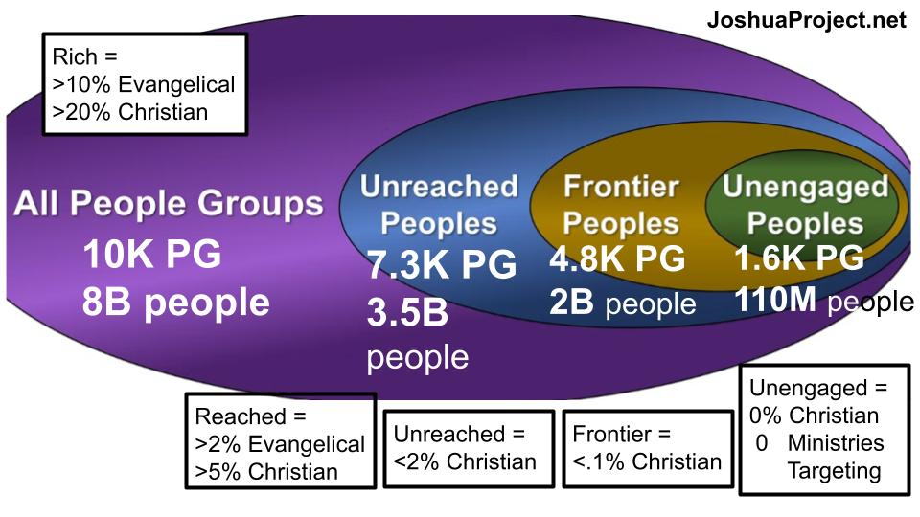The Joshua Project is one of the best ones. You can sign up to get an email every day that shows you one people group you can pray for that remains unreached with the gospel. This visual shows that unreached means less than 2% of the people in that people group is a Christian of any kind. A Frontier group has less than one-tenth of 1% of their people are Christians of any kind. And Unengaged means not a single person among them is a Christian and not a single ministry is working to reach them. Read those numbers if you can see them. Of the 8B people on this planet:
- 3.5B of them are UNREACHED
- 2B of them are FRONTIER
- 110M of them are completely UNENGAGED with the gospel


The SBC has visualized this a little more simply for us:

If the world only had 10 people on it, one of them would be a born again evangelical. 2 would call themselves Christian but wouldn’t clearly understand the gospel. 3 more would not be Christians but would know multiple Christians and have access to the gospel in one way or another.

So, 6 of the 10 people on earth are REACHED in that sense. 60% have access to the gospel. The other 4 people are unreached and 1 of them is completely unengaged. Unreached means that less than 2% of their people group are Christians by any definition. Unengaged means there isn’t a Christian or a Christian ministry accessible to these people at all. Do you feel the weight of this? 40% of the people on earth right now have little or no access to the name of Jesus – the only name under heaven by which you can be saved.

How to make disciples:
- Until Every Person on earth has heard the Good News
“But you will receive power when the Holy Spirit has come upon you, and you will be my witnesses in Jerusalem and in all Judea and Samaria, and to the end of the earth.” Acts 1:8

Acts 1:8 should be an encouragement to us, because Jesus promised it would be fulfilled. But remember, if we don’t obey Acts 1:8 what we get is Acts 8:1 – persecution breaking out that scatters us all over.

And let’s conclude with one more piece of encouraging news.

Who will help us make disciples of all nations?
- Jesus is with us Every Step of the way
“And behold, I am with you always, to the end of the age.” Matthew 28:20

Jesus did not leave us alone to finish this project. He promised to be with us every step of the way, through the person of the Holy Spirit. That’s what Acts 1:8 says as well. So don’t be afraid. Don’t let this make you nervous. The One with all the authority, the One who is worthy of all glory, honor and praise – He is with us every moment and every step until the work is finished. So come on, people. Let’s start right here and bring the Good News as far as we can!

