The Great Commitment
Matthew 16

Today we wrap up our summer series on missions – Living on mission with God. We have heard from a few of our missionaries about how God is working in different places around the world and how they are seeing Him work in and through them now. Between the reports from missionaries and just watching the news, does anyone think the end times might be closer than we have thought? Here is what Jesus said in Matthew 24.

“For many will come in my name, saying, ‘I am the Christ,’ and they will lead many astray. And you will hear of wars and rumors of wars. See that you are not alarmed, for this must take place, but the end is not yet… and there will be famines and earthquakes in various places. All these are but the beginning of the birth pains.” Matthew 24:5-8

What do birth pains do? They get closer together and more intense. More global catastrophes. More conflict. More false Christs. Or if you prefer “Ds”: more deception, more division, more disasters. However you spell it, there feels like more. But there is also good news mixed in with the bad news we should expect.
“And this gospel of the kingdom will be proclaimed throughout the whole world as a testimony to all nations, and then the end will come.” Matthew 24:14
Before the return of Christ and the final judgment, the gospel will reach the ends of the earth. That tells us that one of – maybe the only – reason Jesus hasn’t come back yet, is because there is still work to do to finish this mission. But after the work is done, here is what we know:
“Then will appear in heaven the sign of the Son of Man, and then all the tribes of the earth will mourn, and they will see the Son of Man coming on the clouds of heaven with power and great glory. And he will send out his angels with a loud trumpet call, and they will gather his elect from the four winds, from one end of heaven to the other.”
Matthew 24:30-31
Jesus IS coming back. And every day His return feels closer. To non-believers it will come like the flood of Noah’s day, or like a thief in the night. But Jesus says to His disciples it will be like a woman giving birth or:
“From the fig tree learn its lesson: as soon as its branch becomes tender and puts out its leaves, you know that summer is near. So also, when you see all these things, you know that he is near, at the very gates.” Matthew 24:32-33
I don’t know if any of you were terribly shocked when your baby was born. But our boys took their time in coming, so we had plenty of warning. My parents like to tell the story of how quickly I tried to come into the world, sliding in backwards like I was stealing second. Didn’t work very well, it turns out. (Don’t worry - they did make it to the hospital in time – but just barely.) But even a baby who tries to come quickly doesn’t really surprise his parents. Paul says it this way in 1 Thes.

“While people are saying, ‘There is peace and security,’ then sudden destruction will come upon them as labor pains come upon a pregnant woman, and they will not escape. But you are not in darkness, brothers, for that day to surprise you like a thief.”
1 Thessalonians 5:3-4

Jesus gave us signs to watch for and we have many exhortations in the Bible to stay awake, to pay attention, to keep praying and keep serving our Lord and Master, so we are not surprised or caught off guard when He does suddenly return.

Jesus also gave us comforting promises to help us endure faithfully to the end. Today we will see three of those promises. Let’s start in Matthew 16.

Three Promises from the Lord to help us Persevere:
“I will build my church.”
He said to them, “But who do you say that I am?” Simon Peter replied, “You are the Christ, the Son of the living God.” Matthew 16:15-16

In an area called Caesarea Philippi, Jesus asked his disciples the question, “Who do PEOPLE say that I am?” And they gave some of the common answers: maybe you’re John the Baptist back from the dead, maybe Elijah or Jeremiah (OT prophets, also back from the dead)... Then Jesus turned to the disciples themselves, “What about YOU? Who do YOU say that I am?”

Here is the central question of all of life – the place that everyone has to land eventually. What do you believe about JESUS? To YOU, who is Jesus?

Peter, as usual, was the first to speak up. And in this case, he got the answer spot on. “You are the Christ, the King the Jews had been waiting for from the line of David, the SON of the living God.” Jesus commended him for this answer, giving credit to God the Father lest Peter take any credit for himself. The Jews were watching for the Messiah to come. But Peter was actually pretty insightful to get the second part right about Jesus being the Son of God. Now, if you read the gospel of John, you’ll see plenty of times when Jesus said it explicitly. But it’s hard to know the chronology of exactly when the gospel accounts line up with each other.

Our key passage for this “Join God in His Work” series comes from John 5.
“But Jesus answered them, ‘My Father is working until now, and I am working.’ This was why the Jews were seeking all the more to kill him, because not only was he breaking the Sabbath, but he was even calling God his own Father, making himself equal with God.” John 5:17-18
The Jewish leaders picked up on this teaching of Jesus, and why it was a problem for Jesus to refer to God as His Father – because that made Jesus the Son of God, which meant EQUAL with God. And that was a problematic claim - a blasphemous claim. One the Jewish authorities had to deal with, which was why they felt the need to have him executed.

Do you see why Peter’s statement in Matthew 16 was so significant?

Three Promises from the Lord to help us Persevere:
“I will build my church.”
- The Gospel provides an unshakeable Foundation for the Church
“You are the Christ, the Son of the living God.” Matthew 16:16

To Jesus’ question, Peter makes this bold response: “You are the Christ.” But he didn’t stop there, just claiming Jesus as the Messiah and King. A lot of Jews wanted a Messianic King. They wanted a military king to lead them against Rome. Many of them had been preparing for this event for generations. But few, if any, were looking for the fully divine Son of God to appear wearing that mantle of the Messiah, from the line of David.

It took the disciples, including Peter, a long time to realize who was leading them around Galilee doing miracles, healing people, teaching about a heavenly kingdom. But here in Matthew 16, in a place where people worshiped many local deities and Greek gods like Pan the goat demon, Jesus asked the question directly – “Who do YOU say that I am?”

Peter answered correctly, and Jesus went on from there.

- The Gospel provides an unshakeable Foundation for the Church
“You are Peter (Petros), and on this rock (petra) I will build my church, and the gates of hell shall not prevail against it.” Matthew 16:18

Some of you probably know this verse is debated in terms of WHAT Jesus says he is going to build His church upon. One view is that it is PETER HIMSELF, as an argument to set up the role of bishops and later the pope, placing authority in church leadership. You can see I’ve taken the traditional Protestant view that it is not Peter Jesus is referencing here, but the gospel Peter has just proclaimed about Jesus being the divine Messiah. I think that debate is well settled by the fact that just 5 verses later Jesus calls Peter SATAN, saying “get behind me,” because Peter disagrees with the idea of Jesus suffering and dying.

The apostle Paul confirms that the foundation for the church is the gospel, as summarized in the name of Jesus:

- The Gospel provides an unshakeable Foundation for the Church
“For no one can lay a foundation other than that which is laid, which is Jesus Christ.”
1 Corinthians 3:11

Here is the only name by which one can be saved. Here is the Name above All Names. Here is the center of the gospel we proclaim and on which we depend: Jesus the Messiah, Jesus the King, Jesus the Lord. Our faith, our hope, our lives and our eternity rest on Him. And so does our confidence in the church moving forward to the ends of the earth. Jesus is building His Church and nothing will stop us as we advance in His Name. That’s the first promise we cling to: Jesus saying, “I will build my church.” Second promise:

Three Promises from the Lord to help us Persevere:
“This gospel… will be proclaimed.”
- The Good News will reach all nations
“And this gospel of the kingdom will be proclaimed throughout the whole world as a testimony to all nations, and then the end will come.” Matthew 24:14

Do you see the significance of Jesus’ promise here in Matthew 24? The same passage in which Jesus warns of escalating birth pains and increasing persecution, He also promises that the good news will be unstoppable and will reach to the end of the earth, to every tongue and tribe and nation. Only then, “the end will come.” Jesus says this again in Acts 1, right before He ascends into heaven.

“This gospel… will be proclaimed.”
- The Good News will reach all nations and Peoples
“But you will receive power when the Holy Spirit has come upon you, and you will be my witnesses in Jerusalem and in all Judea and Samaria, and to the end of the earth.” Acts 1:8

Do you see the secret here in Acts 1? Not only was the good news of Jesus for the Jewish people, but God promised it would spread even to SAMARIA – the detestable half-Jews living right next to Judea. And from that center around Israel, the good news would spread to the end of the earth! And indeed, it has and continues to spread!

The book of Acts documents that movement. And history proves the movement has continued. How does the message spread? Has it been through angels and cosmic events like the wise men saw that led them to Baby Jesus? No. It is through everyday Christians simply serving as witnesses, empowered by the Holy Spirit and testifying to what we have seen and heard; what we have experienced in the love and grace of Jesus. Look at how the message of Jesus spread in the book of Acts.
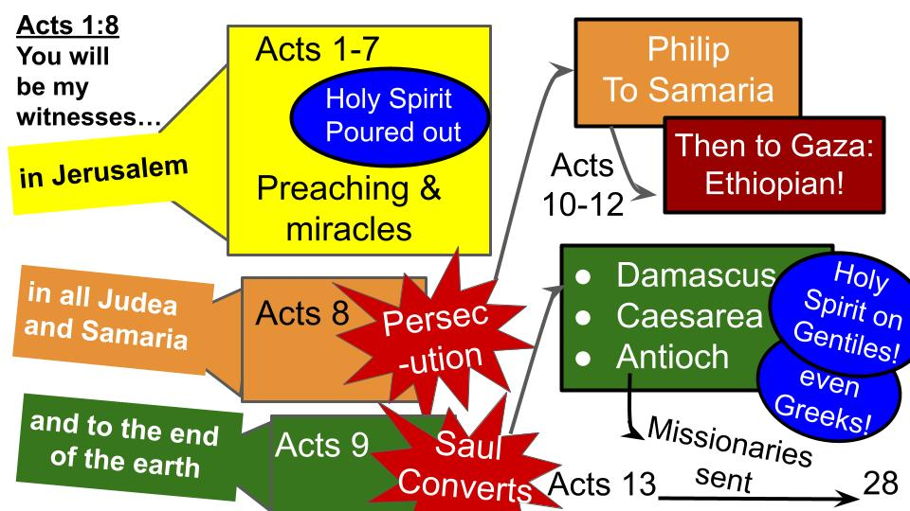
Acts 1:8 provides the structure for all of Acts, showing how the gospel moved from Jerusalem, through all of the region of Judea and even Samaria, and eventually to the end of the known world in those times – to Rome. I know it’s hard to see this slide, but the point is how the gospel advanced as Jesus said it would, with the disciples serving as witnesses to His death and resurrection. Yes, there had to be a great persecution to scatter the believers in Acts 8. And Saul, the Pharisee, had to be confronted directly by Jesus. But then Philip was sent to Samaria, where the people DID respond. And Philip was sent to a special road where he ran into an Ethiopian, of all people. On and on the disciples went, and more and more people responded to the good news, even Gentiles, even Greeks. And it was from Antioch, a Gentile city, that the first missionaries were sent out, to bring the message of Jesus to Asia, Greece, and eventually Italy.

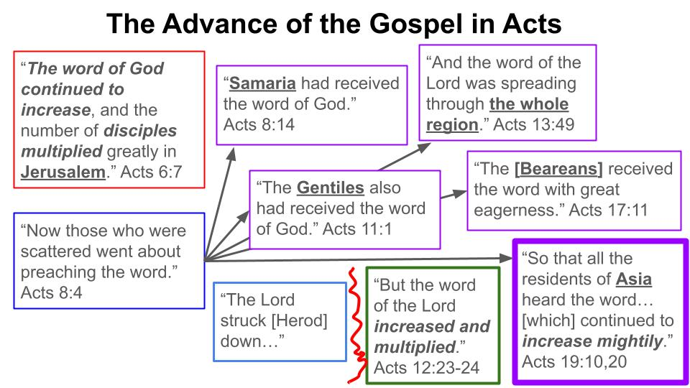
Another interesting way the book of Acts is designed is around the phrase, “the word of the Lord,” meaning the GOSPEL. In the face of great opposition, with apostles being thrown in jail and Paul being chased from one town to another – even being stoned to death once – the gospel keeps moving forward with unstoppable power. Remarkably, even Samaritans and Gentiles and Greeks receive this good news so it spread and multiplied.

Look at the last verse of the book of Acts, showing the result of this advance from Jerusalem.

- The Good News will reach all nations and Peoples through the Church
“[Paul] lived [in Rome] two whole years at his own expense, and welcomed all who came to him, proclaiming the kingdom of God and teaching about the Lord Jesus Christ with all boldness and without hindrance.” Acts 28:30-31

Rome was the center of the world in those days, the seat of power and control over the whole Empire. The fact that the gospel reached Rome through Paul, and that he was free to preach the message of Jesus there, with a growing church there to which he sent a very important letter… shows the fulfillment of Jesus’ promise in Acts 1:8 and in Matthew 24 and Luke 24. The good news will reach all nations, all peoples, THROUGH the Church.

Look at Luke 24.

“This gospel… will be proclaimed.”
- The Good News will reach all nations and Peoples through the Church
“Thus it is written, that the Christ should suffer and on the third day rise from the dead, and that repentance for the forgiveness of sins should be proclaimed in his name to all nations, beginning from Jerusalem. You are witnesses of these things.” Luke 24:46-48

These are the things Jesus declared “WRITTEN” that “HAD TO BE” fulfilled: His own suffering, death and resurrection– followed by the proclamation of the gospel to ALL NATIONS. How would that good news be proclaimed to the end of the earth? Through the witness of the followers of Jesus – the CHURCH. And right now? Through US. We are the continuing witnesses of the power, grace and love of Jesus.

One more promise from the Lord Jesus to help us persevere. Look at Acts 1. You all know that the book of Acts is Volume 2 of Luke’s writing, right? You see Luke 24, the end of Luke’s gospel on the screen. From that page, if you turn it over, your Bible will take you to John chapter one, because the Bible organizers wanted all four gospel accounts side by side (and that was a very reasonable choice). But from Luke’s perspective, you would turn the page from Luke 24 to Acts chapter 1. Then you go from the crucifixion and resurrection of Jesus to His ascension and in Acts 2 the outpouring of the Holy Spirit. And right after Jesus rose into the clouds, two angels spoke to the disciples:

Three Promises from the Lord to help us Persevere:
“I will come again.”
“Men of Galilee, why do you stand looking into heaven? This Jesus, who was taken up from you into heaven, will come in the same way as you saw him go into heaven.”
Acts 1:11

This shouldn’t have been a surprise for Jesus’ followers. Look back at John 14, before Jesus was arrested.

Three Promises from the Lord to help us Persevere:
“I will come again.”
“And if I go and prepare a place for you, I will come again and will take you to myself, that where I am you may be also.” John 14:4

This is the famous passage where Thomas says, “We don’t know where you’re going. How can we know the way?” and Jesus responds, “I AM THE WAY…” The Great I Am came to live among us and laid down His life to become the way of salvation for all who would believe in Him. “I am the way.” And with that promise of being the way of salvation came the promise of coming back for all who trust in Him. “I will come again.”

“I will come again.”
- The Glorious Return of Jesus will bring final justice
“So that at the name of Jesus every knee should bow, in heaven and on earth and under the earth, and every tongue confess that Jesus Christ is Lord, to the glory of God the Father.” Philippians 2:10-11

The first fact to know about the return of Jesus is that it will be GLORIOUS. His glory will be visible to everyone on earth and every knee will bow before Him. Every person will confess the truth of the gospel that Jesus Christ is Lord. In that moment everyone will give glory to God the Father, of which He alone is worthy. Then will come the final separation. Justice.

- The Glorious Return of Jesus will bring final justice
“When the Son of Man comes in his glory, and all the angels with him, then he will sit on his glorious throne. Before him will be gathered all the nations, and he will separate people one from another as a shepherd separates the sheep from the goats.”
Matthew 25:31-32

Matthew 25 presents all these different groups, one side to receive a reward, the other to receive a punishment. 5 young women prepare for the wedding and are rewarded. 5 other women don’t prepare and are punished. 3 men are given money to invest. Two get right to work and produce a return and the Master commends them. One does nothing and gets rebuked by the Master. Then comes this ending with the sheep and the goats being separated.

- The Glorious Return of Jesus will bring final justice
“And these will go away into eternal punishment, but the righteous into eternal life.” Matthew 25:46

Eternal. Those who served the Lord into eternal life, joy and blessing. Those who did not trust in or serve Jesus into eternal punishment, suffering, weeping and gnashing of teeth. Final justice. But also full restoration.

- The Glorious Return of Jesus will bring final justice and full Restoration
“God himself will be with them as their God. He will wipe away every tear from their eyes, and death shall be no more, neither shall there be mourning, nor crying, nor pain anymore, for the former things have passed away.” Revelation 21:3-4

The return of Christ is in Revelation 19, after all the tribulation and judgment. Seals open, trumpets blow, bowls poured out. Then boom, one last trumpet and the clouds part, and there is Jesus on the white horse, leading the armies of heaven. His victory will not be with swords or guns, but with the word from His mouth simply saying, “It is done.” After 1,000 years on this planet, as it is, we turn the page to Revelation 21, and now God is walking directly with us, as He did with Adam and Eve. And the Good Shepherd wipes away every tear, brings an end to death and suffering and sadness forever. And God makes all things new. Final justice and full restoration. The glory of God now united with a renewed mankind, as the full beauty of the church is unveiled in the holy city, the New Jerusalem, coming down out of heaven like a bride for King Jesus.

Do you feel the beauty and power of these precious promises?

Three Promises from the Lord to help us Persevere:
- “I will build my church.”
- “This gospel… will be proclaimed.”
- “I will come again.”

Hear these words directly from Jesus to you.
- “I will build my church.” Nothing can stand against the body of Christ advancing in Jesus’ Name. Even the gates of hell cannot stop us as Jesus builds us up like a holy temple, one brick at a time.
- “This gospel of the kingdom will be proclaimed in all nations.” Don’t be afraid as you pray and prepare to share the good news with a family member or friend. The Holy Spirit will give you the words and you are just participating in the unstoppable work of King Jesus. It was written before time began that this work would be accomplished. We simply have the privilege to join in the work!
- “I will come again.” Jesus knew his followers would face great opposition and tribulation and persecution. He knew how much encouragement and support we would need. So He made these wonderful promises to keep us going and to keep our eyes on that finish line, when our Lord and King would come back and we would be together with Him forever.

1 Thessalonians commands us to encourage one another with these particular words. So hear them and be encouraged.

“For the Lord himself will descend from heaven with a cry of command, with the voice of an archangel, and with the sound of the trumpet of God. And the dead in Christ will rise first. Then we who are alive, who are left, will be caught up together with them in the clouds to meet the Lord in the air, and so we will always be with the Lord. Therefore encourage one another with these words.” 1 Thessalonians 4:16-18

Look to the person next to you and say, “Jesus is coming back soon.”
Then respond back, “Be encouraged.” Amen.

